Shaik Sharifa Jahan

AP22110011103

1. Write a program in assembly language to print “Hello World”.

org 100h

jmp start

msg: db "Hello, World!",0Dh,0Ah,24h

start: mov dx,msg

mov ah,09h

int 21h

mov ah,0

int 16h

ret

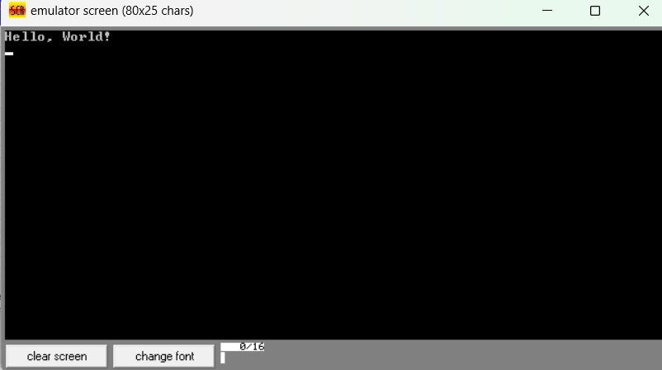

2. Write an assembly language program to print your name.

org 100h

jmp print

welcome: db "Shaik Sharifa Jahan",0Dh,0Ah,24h

print: mov dx,welcome

mov ah,09h

int 21h

mov ah,0

int 16h

ret

